ANLY 501 Project 1 Report

Georgetown University

Min Xiao, Tianyu Yang, Cheng Zhong

Oct 6th 2017

**Data Science Problem**

Music evolves from simple patterned sounds back in ancient time to a rich, well developed, and universal culture around the world. Meanwhile, the uniqueness and commonness long existed in the population lead to discrepancy in tastes and contributes to formations of music genres. One might accurately identify the type of a song with perception, yet such self-developed standard hardly ever tells the whole story about either the song or the genre. Nowadays, we are no longer restricted by perception based criteria. Instead, quantitative measures that describe music features and widely used in music analysis, could assist us in providing more insights in a song and the genre it belongs(Ridley and Dumovic, 2016). In this study, we hope to establish a relationship between the sound features and music classification. Meanwhile, by associating with music ranking, we would also like to explain music trending on a fundamental level.

**Data Collection and Potential Analysis**

We plan to use playlist and soundtrack data from Spotify. Spotify develops categories for playlists, which we will be using as proxies for music genre. Besides, Spotify also has detailed metrics for sound features, which quantitatively and thoroughly describe the sound tracks. Each song and playlist have unique ids, giving conveniences when merging the datasets. The Spotify data offers a well-constructed platform where we can conduct analysis for our research goal. For music ranking, we will collect billboard weekly music rankings including the overall rank and ranks by music genre, which provides channels for more detailed analysis involving trending. On the aspect of analysis, we are able to conduct either descriptive or predictive analysis with the versatile datasets obtained from Spotify and Billboard. A few topics we interested in includes:

* what are the similarities among audio features for sleeping time music and dining music?
* what is the most important feature given the music genre?
* what are the differences among R&B, Blues, and soul music on the fundamental level?
* Prediction of ranking position using sound feature
* what is audio feature’s role in music classification?

and so on.

**Variable Description**

**Spotify Dataset (developer.Spotify.com/web-api/object-model/)**

***Playlist ID (string)***: The Spotify ID for the playlist containing  
the sound track

***Sound Track ID (string)***: The Spotify ID for the track

***Album(string)***: The album on which the track appears

***Artist (string***): The artists who performed the track

***Available Market(string):*** A list of the countries in which the track can be played, identified by their ISO 3166-1 alpha-2 code

***Duration(integer):*** The track length in milliseconds.

***Song Name***: name of the song

***Category(string):*** The name of the category.

***Popularity (integer)***: The popularity of the track. The value will be between 0 and 100, with 100 being the most popular.

***Acousticness(float):*** A confidence measure from 0.0 to 1.0 of whether the track is acoustic. 1.0  
represents high confidence the track is acoustic.

***Danceability (float):*** Danceability describes how suitable a track is for dancing based on a  
combination of musical elements including tempo, rhythm stability, beat strength, and overall regularity. A value of 0.0 is least danceable and 1.0 is most danceable.

***Energy(float)***: Energy is a measure from 0.0 to 1.0 and represents a perceptual measure of intensity and activity. Typically, energetic tracks feel fast, loud, and noisy. For example,  
death metal has high energy, while a Bach prelude scores low on the scale. Perceptual features contributing to this attribute include dynamic range, perceived loudness, timbre, onset rate, and general entropy.

***Instrumentalness (float)***: Predicts whether a track contains no vocals using float ranging from 0 to 1. "Ooh" and "aah" sounds are treated as instrumental in this context. Rap or spoken word tracks are clearly "vocal". The closer the instrumentalness value is to 1.0, the greater likelihood the track contains no vocal content. Values above 0.5 are intended to represent instrumental  
tracks, but confidence is higher as the value approaches 1.0.

***Key(integer)***: The key the track is in. Integers map to pitches using standard Pitch Class notation.  
E.g. 0 = C, 1 = C♯/D♭, 2 = D, and so on. Integers from 0 to 11.

***Liveness(float)***: Detects the presence of an audience in the recording ranging from 0 to 1. Higher  
liveness values represent an increased probability that the track was performed  
live. A value above 0.8 provides strong likelihood that the track is live.

***Loudness(float):*** The overall loudness of a track in decibels (dB). Loudness values are averaged  
across the entire track and are useful for comparing relative loudness of tracks. Loudness is the quality of a sound that is the primary psychological correlate of physical strength (amplitude). Values typical range between -60 and 0 db.

***Mode(integer)***: Mode indicates the modality (major or minor) of a track, the type of scale from  
which its melodic content is derived. Major is represented by 1 and minor is 0.

***Speechiness(float)***: Speechiness detects the presence of spoken words in a track. The more  
exclusively speech-like the recording (e.g. talk show, audio book, poetry), the closer to 1.0 the attribute value. Values above 0.66 describe tracks that are probably made entirely of spoken words. Values between 0.33 and 0.66 describe tracks that may contain both music and speech, either in sections or layered, including such cases as rap music. Values below 0.33 most likely represent music and other non-speech-like tracks.

***Tempo (float)***: The overall estimated tempo of a track in beats per minute (BPM). In musical terminology, tempo is the speed or pace of a given piece and derives directly from the average beat duration.

***Time Signature (integer)***: An estimated overall time signature of a track. The time signature (meter) is a notational convention to specify how many beats are in each bar (or measure).

***Valence (float):*** A measure from 0.0 to 1.0 describing the musical positiveness conveyed by a track. Tracks with high valence sound more positive (e.g. happy, cheerful, euphoric), while  
tracks with low valence sound more negative (e.g. sad, depressed, angry).

**Billboard Dataset**

***Artist (string)***: Name of the artist.

***Last Position (integer)***: Last week’s ranking position.

***Peak Position (integer)***: Highest ranking position.

***Rank (integer)***: Current ranking position.

***Title (string)***: Name of the song.

***Weeks (integer)***: The number of the weeks the song stays on the billboard rank.

***Date (datetime)***: releasing date of the ranks.

***Genre (String):*** Name of the ranking genre

**Data Collection**

To collect data from Spotify, we used the ‘spotipy’ package from github. Spotify started to uses Oauth2 authentication for every request. Using the package simplifies our workflow for extracting data. To avoid privacy issues, we only obtained information in the public scope. To start with, we identified the category names listed on Spotify. Then we used the category names as searching keywords to get related playlists. After, using the sound track ids contained in the playlists, we were able to acquire information on the soundtracks and their audio features. Finally, we merged the sound track information and audio features meanwhile assigning a new variable indicating what category name the songs belonged to.

To collect data from Billboard, we used the ‘billboard.py’ package from github. The package generalized the web scraping process to functions with given searching parameters. We picked three overall rankings: ”Hot 100”, “Billboard 200” and “Greatest Hot Singles 100’’, and one ranking in each of the nine categories Billboard has and acquired rankings in the past year (the most recent 51 weeks from Sept. 30 2017). At the end, we merged the all the rankings, meanwhile assigning a new variable indicating the genre.

**Data Issues**

For the Spotify dataset, given the collection methods, object models of Spotify and the nature of data recording, we anticipate issues rising from the following perspective: missing value, bad value, wrong data type, collapsing of dimensions, and irrelevant variables. To start with, the raw dataset contains variables irrelevant to the study, only for internal use. Such variables should be dropped. Then, since the dataset is multidimensional, making accurate projections in a reduced dimension according to axes requires extracting information from the higher dimensional object (json string). Next, we may have variables with wrong data type, missing values, and bad values (out of bounds). Under the current work flow, we will not be able to identify outliers, and inliers which requires further analysis of the data (Broeck, Jan Van den et al., 2005).

**Data Cleanliness**

To develop a criterion for the cleanliness of the data, we used the score composed by the sum of errors (missing values, bad values, wrong data type) percentages. Duplicates and irrelevant variables were deleted beforehand. Our quality score here ranged from 0 to 100. Our formula to calculate the quality score for spotify data is (1-missing value percentage)*50 + (1-out of range percentage)*50. And the formula for billboard data is (1-missing value percentage)*45 + (1-out of range percentage)*45 + (1-logical error percentage)*10. That is, 100 is the highest score which represent the data is very clean and the lower the score, the “dirtier” the variable. The quality score table for two datasets are shown below:

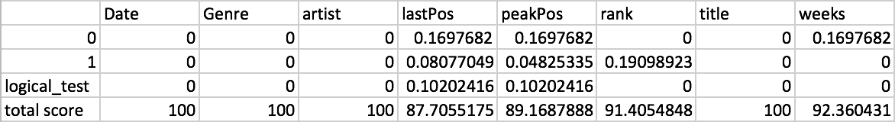

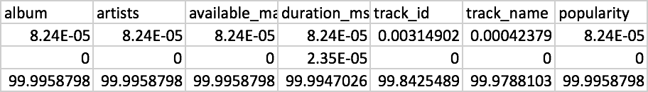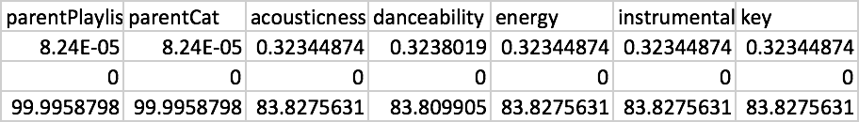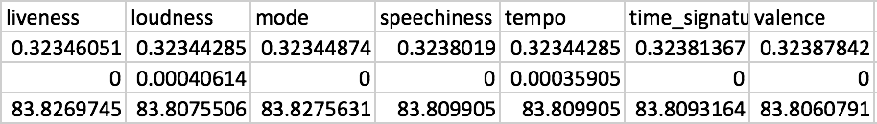

The tables above show that the missing value percentage represents the fraction of missing values for each attribute, and the out of range percentage represents the fraction of noise values and out of range values. All of our variables scored higher than 80, suggesting that overall, the datasets are clean on a broad sense. While all variables have missing values, a few contains out-of-range values, and only to a small proportion. In between datasets, the Billboard dataset is cleaner with a higher median score since it contains fewer variables, has a simpler structure and the numerical variables themselves are integer based. One other observation is that the scores for the Spotify variables are roughly in two clusters. We speculate that the values for audio feature variables were all recorded at once, meaning that missing in one would result in missing in all others.

Median score for Billboard ：95.755， mean: 94.8167

Median score for spotify ：83.8275， mean: 90.74

**Data Cleaning**

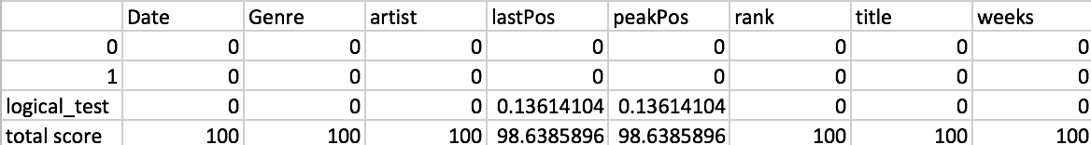

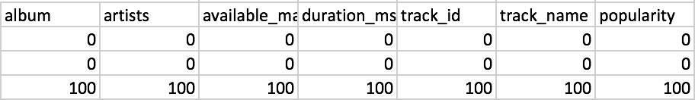

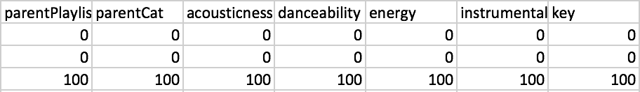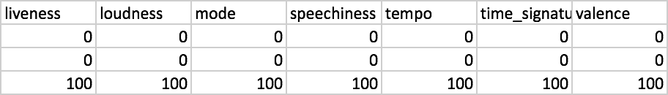

The above table shows the cleaning score after we cleaned the data. By removing the blank rows and duplicate rows, replacing the missing cells with mean or median, dropping all the missing cells in string type columns, we obtained two clean datasets available for our first round of analysis. All the cleaning scores were enhanced to 100 for the spotify dataset, and the scores for the Billboard enhanced to more than 98. Overall, the cleaning procedures were effective and necessary in the pre-analysis phase.

**Works Cited:**

Ridley, Richard, and Mitchell Dumovic. “Classification of Artist Genre through Supervised Learning.” Oct. 05 2017

Broeck, Jan Van den; Cunningham, Solveig; Argeseanu Eeckels; Roger, Herbst. “Data Cleaning: Detecting, Diagnosing, and Editing Data Abnormalities” Oct. 05 2017